Section I
Total Marks (75)

Part A
Total marks (15)
Attempt Questions 1-15
Allow about 30 minutes for this part

INSTRUCTIONS
Use the multiple choice answer sheet below.
Select the alternative A, B, C or D that best answers the question. Fill in the response square completely.

Sample 2+4= (A) 2 (B) 6 (C) 8 (D)9

A  B  C  D 

If you think you have made a mistake, put a cross through the incorrect answer and fill in the new answer.

A  B  C  D 

If you change your mind and have crossed out what you consider to be the correct answer, then indicate this by writing the word correct and drawing an arrow as follows:

correct

A  B  C  D 

_________________________________________________________________________________________
1.Which set of aqueous solutions contain [H₃O⁺] less than 10 ^{–7} mol L ^{–1} ?

- CH₃COOH, HCl, H₂SO₄
- NaCl, NH₃, H₂CO₃
- C₆H₁₂O₆, C₂H₅OH, CH₃COOH
- Na₂CO₃, Ca(OH)₂, NaHCO₃
Outcome: H8

Answer: D

2. Which of the following is a segment of the structure of cellulose?

(A)
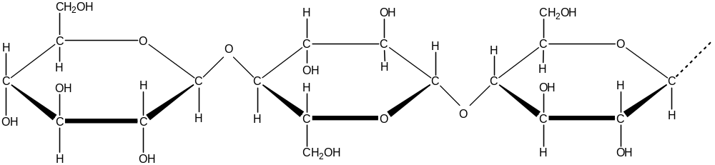

(B)
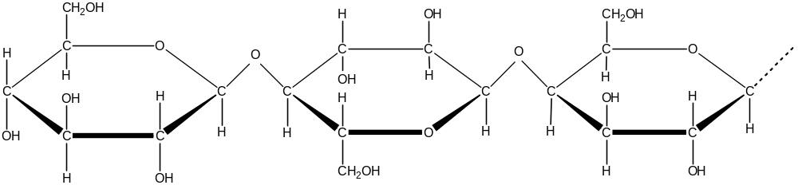

(C)
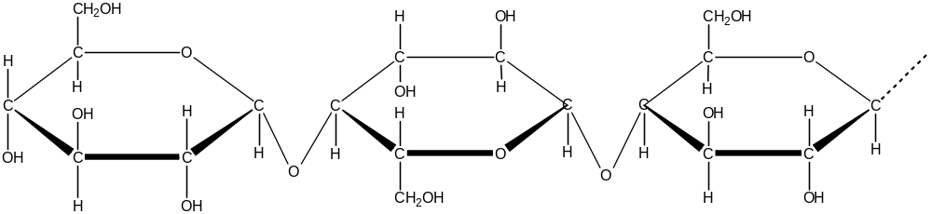

(D)
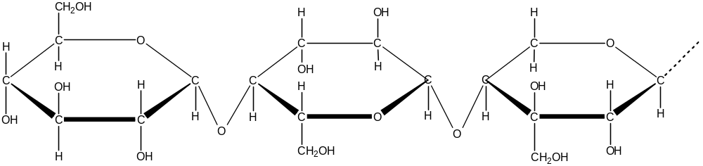

Outcome: H9

Answer: A

3. Which of the following galvanic cells would produce the greatest voltage?

(A) 3Mg _{(s)} + 2Al³⁺ → 2Al _{(s)} + 3Mg²⁺
(B) Sn _{(s)} + Pb²⁺ → Sn²⁺ + Pb _{(s)}
(C) Zn _{(s)} + Cu²⁺ → Zn²⁺ + Cu _{(s)}
(D) 2Ag⁺ + Cu _{(s)} → 2Ag _{(s)} + Cu²⁺

Outcome: H8
Answer: C

4. These half-reactions show manganese gaining electron(s) and becoming reduced. In which of the half-reactions is manganese being reduced to the greatest extent?

(A) MnO₄– + a e– → MnO₄^{2–}
(B) Mn²⁺ + b e– → Mn _{(s)}
(C) MnO₂ _{(s)} + 4H⁺ + c e– → Mn²⁺ + 2H₂O
(D) MnO₄– + 4H⁺ + d e– → MnO₂ _{(s)} + 2H₂O

Outcomes: H8, H10

Answer: D

5.Which reaction shows a transuranic element being produced?

(A)
(B) 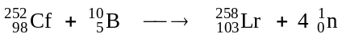
(C) 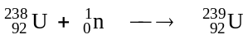
(D) 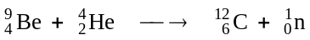
Outcomes: H8, H10

Answer: B

6. Repairs are done on a cracking unit at an oil refinery. An analytical chemist is asked to test the product output from the cracking unit to ensure proper operation.
Which of the following would be a valid test?

(A) test with a homologous catalyst
(B) test with limewater
(C) test with bromine water
(D) test with methyl orange

Outcome: H8

Answer: C

7. Which of these is the structure of styrene?

(A)
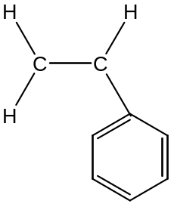 (B)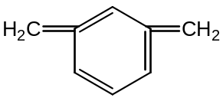
(C)
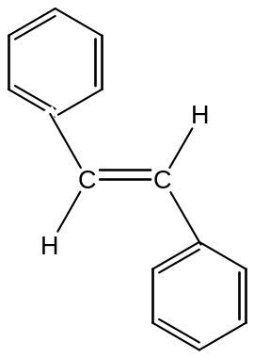 (D) 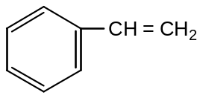

Outcome: H9

Answer: D

8. Which lower atmosphere pollutant and its source is incorrectly listed?

 | Pollutant | Source
(A) | ozone | photochemical smog
(B) | sulfur dioxide | metal extraction
(C) | carbon monoxide | motor cars
(D) | oxides of nitrogen | combustion (impurities in the fuel)

Outcome: H4

Answer: D

9. Which technique or instrumentation would be most useful in qualitatively
identifying very low concentrations of heavy metal ions in solution.

(A) Atomic Absorption Spectrometry
(B) pH meter
(C) flame test
(D) precipitation with suitable reagents
Outcome: H13

Answer: no correct answer

10. Which is the correct IUPAC name for citric acid?

(A) 2-hydroxypropane-1,2,3-tricarboxylic acid
(B) 2-hydroxypropane-triethanoic acid
(C) 1,1,1-tricarboxylic acid
(D) ethanoic acid

Outcome: H9

Answer: A

11. The 'sour' taste of fruits is often caused by the presence of alkanoic acids. The functional
group responsible for the properties of alkanoic acids is

C
║
O
(A)
(B)
(C)
H
C
║
O
C
║
O
OH
(D)

C
OH
│
│

Outcome: H9

Answer: C

12. High concentrations of SO₂ have been blamed for the increased mortality rates occurring in
times of 'smog'.
Which process would NOT release SO₂ into the atmosphere?

(A)the action of water on superphosphate fertilizers
(B) the combustion of crude oil
(C) the oxidation of sulfide ores in a smelter
(D) large eruption volcano emissions

Outcome: H4, H16

Answer: A

13. Sulfuric acid can react with pyrosulfuric acid according to the equation:

H₂SO₄(l) + H₂S₂O₇ (l) H₃SO₄⁺(l) + HS₂O₇⁻(l)

Which species are acting as acids in this reaction?

(A) H₂SO₄, H₃SO₄⁺
(B) H₂S₂O₇, HS₂O₇⁻
(C) H₂SO₄ , HS₂O₇⁻
(D) H₂S₂O₇, H₃SO₄⁺
Outcome: H8

Answer: D

14. Which type of glassware is used in titration to deliver solution X to a known volume
of solution Y?

(A) 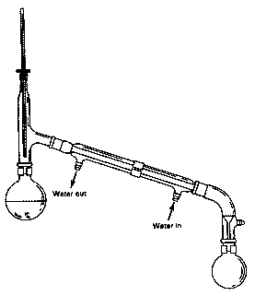 (C)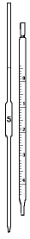
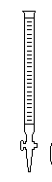
(B)  (D)

Outcome: H12

Answer: D

15. Which statement corresponds best with Davy's ideas about acids and bases?

(A) An acid is a substance that provides H⁺ ions in aqueous solution.

(B) All acids contain the element hydrogen.

(C) The presence of oxygen in compounds formed from non-metals, causes acidity.

(D) An acid is a proton donor.
Outcome: H1

Answer: B

Student Number …………………………

Section A Mark -----/15

Multiple Choice Answer Sheet

1. A  B  C  D 

2. A  B  C  D 

3. A  B  C  D 

4. A  B  C  D 

5. A  B  C  D 

6. A  B  C  D 

7. A  B  C  D 

8. A  B  C  D 

9. A  B  C  D 

10. A  B  C  D 

11. A  B  C  D 

12. A  B  C  D 

13 A  B  C  D 

14. A  B  C  D 

15. A  B  C  D 

JAMES RUSE AGRICULTURAL HIGH SCHOOL
2003 CHEMISTRY TRIAL HSC EXAM Student Number …………………………

Section I (continued)

Part B - 60 marks
Attempt Questions 16 -28
Allow about 1 hour and 45 minutes for this part

Answer the questions in the spaces provided
Show all relevant working in questions involving calculations

Question 16 (3 marks) MARKS

During the last twelve months, much media coverage has been devoted to the controversial
use of ethanol as an additive to petrol.

(a) Explain why ethanol is added to petrol. 1

Outcome: H4

Answer: Ethanol is added to petrol to reduce the consumption of oil which is a non-renewable resource. OR Ethanol is added to petrol to reduce greenhouse gas emissions.
OR Ethanol is added as an octane booster.

(b) Evaluate the success or otherwise of the use of ethanol–petrol fuel blends based on
recent Australian experience 2

Outcome: H3

Answer: The use the ethanol–petrol blends has been of mixed success. (1 mark)
Blends with of ≤ 10% ethanol appear compatible with modern motors, however blends sold with up to 20% ethanol have caused damage to fuel lines and the engine. Car makers have threatened to void new car warranties if owners use high ethanol fuel.
Based on recent field trials, the Federal government will legislate to cap ethanol content at 10%. (1 mark)

Question 17 (4 marks) MARKS

Biopolymers have a long history of use (e.g. cellulose and rubber), but much chemical
research is proceeding on a new generation of biopolymers with exciting potential applications.

Complete the table providing information about a recently developed biopolymer you have
studied. 4

Name of biopolymer
Specific enzyme or organism used
to synthesize the biopolymer
Possible use of biopolymer
Property of the biopolymer
which relates to it use
Outcome: H5

Answer: Each cell = 1 mark. Several answers are possible including…

Name of biopolymer | Polylactic acid (Must be name not abbreviation)
Specific enzyme or organism used  to synthesize the biopolymer | fermenting bacteria
Possible use of biopolymer | food packaging
Property of the biopolymer  which relates to it use | transparent, strong, moisture & grease resistant, heat sealable

Question 18 (4 marks)

(a) The following nuclear reaction is incomplete.
Re-write the entire equation providing the missing numbers and/or symbols. 1

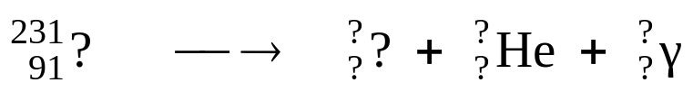

Outcomes: H8, H10

Answer: 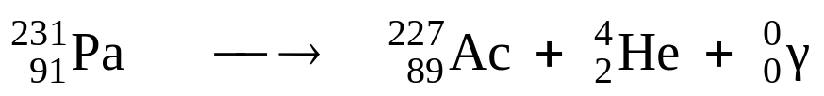

(b) Identify an instrument (other than a Geiger counter) which could be used to
detect radiation. 1

Outcome: H4

Answer: One of the following: cloud chamber, bubble chamber, scintillation counter, dosimeter.
N.B. Photography film is unacceptable as it is not an instrument.

(c) Cobalt–60 is widely used for the irradiation of cancerous tumours because it is a
potent gamma–emitter.

Identify a problem (for patient and radiotherapist) with its use and explain how
the problem is overcome 2

…………………………………………………………………………………………

…………………………………………………………………………………………
Outcome: H4

Answer: Gamma radiation poses a serious biohazard to all healthy tissue in the patient and/or radiotherapist. (1 mark)

The problem is solved by providing adequate lead shielding and directing a narrow beam of gamma rays specifically to the tumour. (1 mark)

Question 19 (3 marks)

(a) Discuss the need for alternative, non-oil based sources of petrochemicals in the future. 2
Outcomes: H3, H4

Answer: Oil is a limited, non-renewable resource. (1 mark)

Since petrochemicals (e.g. plastics, lubricating oil, grease, motor fuels) are essential for industry and technology, alternatives must be found. (1 mark)

(b) The structure shown is a fragment of a cellulose molecule….

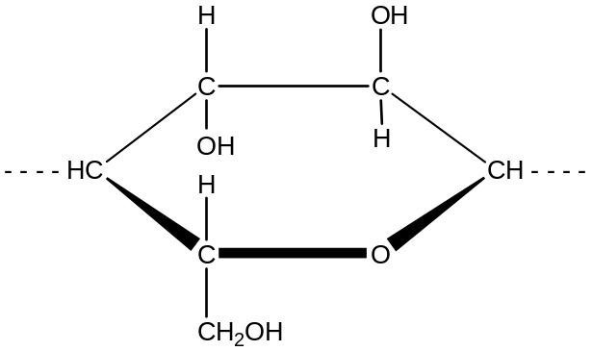

Draw a complete, unbroken border around the part of the structure, which could be
used in the future to make oil-like substitutes 1

Draw a complete, unbroken border around the part of the structure which could be used in the future to make oil-like substitutes. (1 mark)

Outcome: H9

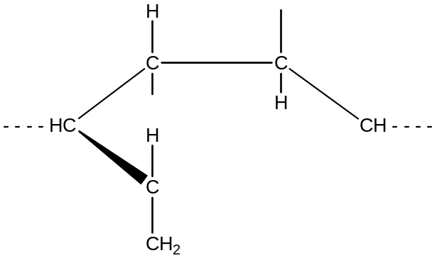

Answer: Border should enclose only the hydrocarbon content of the molecule.

Question 20 (4 marks)

(a) Explain the chemistry of the dry cell or lead-acid cell in terms of oxidation and
reduction. Support your answer with equation data. 2

Outcome: H8

Answer: DRY CELL…
Oxidation: Zn _{(s)} → Zn²⁺ + 2e– (1 mark)

Reduction: NH₄⁺_{(aq)} + MnO₂ _{(s)} + H₂O _{(l)} + e– → Mn(OH)_{3 (s)} + NH_{3 (g)} (1 mark)

OR

LEAD–ACID….

Oxidation: Pb²⁺ + SO₄^{2–} → PbSO₄ _{(s)} + 2e– (1 mark)

Reduction: PbO₂ _{(s)} + SO₄^{2–} + 4H⁺ + 2e– → PbSO_{4(s)} + 2H₂O _{(l)} (1 mark)

*Student could also give the complete reaction equation and then clearly state species undergoing oxidation and reduction.

(b) Describe the flow of electrons in an operating galvanic cell in terms of anode
and cathode. 2
Outcome: H8

Answer: The electrons flow from the anode to the cathode (1 mark) …
through the external circuit. (1 mark)

Question 21 (8 marks)

An alcoholic fermentation is performed to quantitatively determine the mass loss during the
course of the reaction. An aqueous glucose mixture is fermented in a vessel resting on the
pan of an electronic balance, which is connected to a data logger, set to record the mass at one
hour intervals.

(a) Draw a labelled diagram of a fermentation vessel suitable for the purpose of this
investigation. 1

Outcome: H11
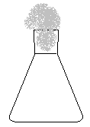
Answer: A labelled diagram showing a flask with a cotton wool plug which allows the release of CO₂ while preventing the entry of fresh air and aceti bacteria.

(b) Describe storage conditions for the vessel, which would favour the 12-hour fermentation 1
Outcome: H11

Answer: A warm ambient temperature (25 – 35°C).

(c) The table shows the downloaded file from the data logger.

Elapsed Time (h) | Mass of vessel (g) | Elapsed Time (h) | Mass of vessel (g)
0 | 173.25 | 7 | 170.40
1 | 173.10 | 8 | 170.35
2 | 172.50 | 9 | 170.30
3 | 171.15 | 10 | 170.25
4 | 170.75 | 11 | 170.25
5 | 170.60 | 12 | 170.25
6 | 170.50

Plot the table data on the graph grid. 2

Question 21 (continuation)


Outcome: H13

Answer: Reasonable y-axis scale; labelled axes with units. (1 mark)
Accurate plotting of 13 data points. (1 mark)

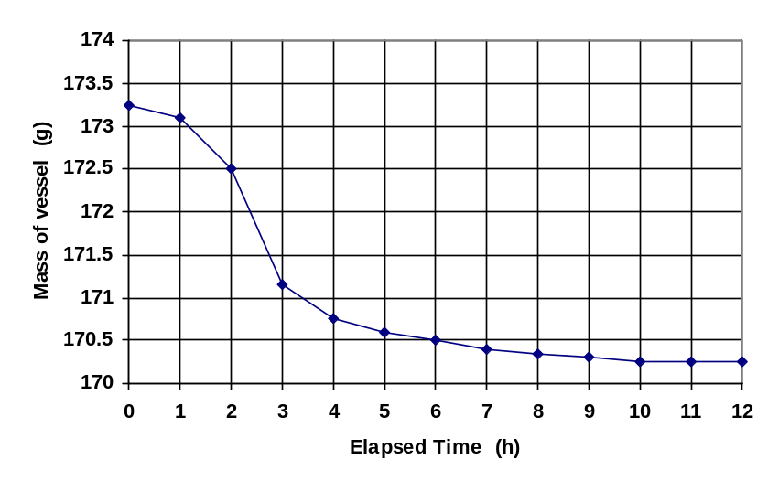

(d) During which one-hour interval was the fermentation most active ? 1

Outcome: H14

Answer: Between 2 – 3 hours.

(e) Suggest a plausible cause for the plateau on the graph 1

Outcome: H14

Answer: All the glucose has been consumed by the yeast.

OR

The build up of ethanol has killed the active yeast.

(f) Write the formulae equation for the fermentation process. 1
Outcome: H9

Answer: C₆H₁₂O₆ _{(aq)} 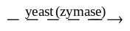 2C₂H₅OH _{(aq)} + 2CO₂ _{(g)}

Must include yeast (zymase).

(g) Calculate the volume of carbon dioxide gas which escaped (at STP) after 6 hours of
fermentation. 1

Outcome: H10

Answer: After 6 hours, mass of CO₂ was lost = 173.25 g – 170.50 g = 2.75 g

∴ 2.75 g ÷ 44.01 g/mol • 22.71 L/mol = 1.42 L

MARKS
Question 22 (4 marks)

CFCs and halons have been identified as the main causes of the upper atmosphere
ozone layer depletion.

(a) Identify one origin of CFCs and one of halons in the atmosphere. 1
Criterion | Mark(s)
Origin of both CFCs and halons | 1

Outcome:H3, H13, H16
Answer:
CFCs were widely used as refrigerants and propellants in aerosol cans while halons
were mainly used in fire extinguishers used in cars and boats. Through time, because of their inherent insolubility in water and unreactivity CFCs and halons found their way into the stratosphere.

(b) The graph shows the mean October ozone concentrations over the south pole. Describe
the changes observed and explain how this information
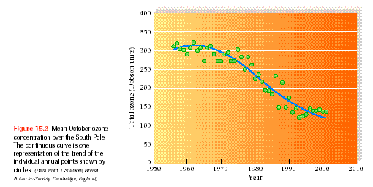
was obtained. 3

Diagram taken from Chemistry in your Life, by C. Baird and W. Gloffke, Freeman, 2003
Criteria | Mark(s)
Description of changes | 1
How information was obtained | 1
Explanation of how information was obtained | 1

Outcomes: H4,H16
Answer:

The diagram shows the annual spring ozone concentration over the south pole
which shows a steady decline in the ozone concentration starting in the mid-1960s.
This is followed by a greater rate of decline between 1970 and 1990. The rate seemed to
have slowed down starting mid 1990s.
The information was most probably gathered from ground -based instruments,
from instruments in a satellite and from instruments in balloons. In the ground-based
instruments UV spectrophotometers are pointing vertically upwards through the
atmosphere. The intensity of the light received from the sun at a wavelength at which
ozone absorbs and then at wavelengths at either side of this at which ozone does not absorb
is measured. .Spectrophotometers on board satellites have been able to
scan through the atmosphere measuring the ozone concentration as a function of
altitude and geographical position.

Question 23 (4 marks)

Ammonium sulfate has been used as fertilizer. Analysis of fertilizer is often done
gravimetrically

(a) Write the main formulae equation for the gravimetric determination of sulfate in fertilizer 1

Criteria | Mark(s)
balanced equation formulae equation | 1

Outcome: H13
Answer:

BaCl₂ + (NH₄)₂SO₄ → BaSO₄(s) + 2 NH₄Cl

(b) Based on the data given below, calculate the percentage sulfate in a fertilizer
sample. 2

mass of fertilizer: = 0.5010 g
mass of sintered glass crucible = 20.2052 g
mass of sintered glass crucible + dried precipitate = 20.7351 g

Outcome: H13, H10

Criteria | Mark(s)
Correct moles of BaSO₄ | 1
Correct percentage sulfate | 1

Answer:
mass of BaSO₄(s) = mass of crucible + precipitate - mass of empty crucible
= 20.7351 - 20.2052 = 0.5299 g

moles BaSO₄ = mass BaSO₄/ molar mass BaSO₄ = (0.5299/ 233.39) = 2.270 x 10⁻³ mole
mole SO₄²⁻ = moles BaSO₄ = 2.270 x 10⁻³ mole 1
mass SO₄²⁻ = moles SO₄²⁻ x molar mass SO₄²⁻ = 2.270 x 10⁻³ mole x 96.06 g/mole
= 0.2181 g

% SO₄²⁻ = mass SO₄²⁻ / mass sample = (0.2181 g/ 0.501 g) x 100 % = 43.5 % 1

(c) Identify one source of error in this determination. Explain how this error will affect the
percentage sulfate determined? 2

Outcome: H14
Answer:
A source of error in this determination is the incomplete precipitation of the sulfate ion as BaSO₄₌
in the fertilizer. This mistake will result in a negative error, a lower reported percentage sulfate
compared with the true value

Another source of error is the incomplete washing of the barium sulfate precipitate. This results
in a higher measured mass of barium sulfate and hence a higher percentage of sulfate in the
fertilizer. compared with the true value.
Inefficient/ineffective filtration method/medium
MARKS

Question 24 (5 marks)

Describe and assess the effectiveness of methods used to purify and sanitize mass water
supplies. 3

Outcome: H16,H3,H14
Criteria | Mark(s)
Description of the methods | 1
Other methods stated | 1
Assessment of the methods | 1

Answer:
Water treatment consists of removing very small particulate by flocculation.. The water is then
sand filtered to remove bigger particulate. Finally, it is treated with chlorine to kill
microorganisms. .Alternative methods of filtration such as membrane filtration and ozone
sterilization may be both more efficient in removing particulate including microorganisms such
as Giardia and Cryptosporidium. However, these latter techniques are expensive to
implement.

Question 25 (4 marks)

Outline the role of a chemist employed in a named industry or enterprise. Identify the branch
of chemistry undertaken by the chemist and describe a chemical principle that the chemist
uses. 4
Outcomes: H3
Answer:

Criteria | Mark(s)
Named Industry | 1
Branch of Chemistry | 1
Chemical Principle used | 1
Brief outline of Chemists role | 1

Plastics industry as a plant chemist. This is a branch of Organic chemistry. Catalytic
cracking is used to change the long chain alkanes to shorter chain alkanes which can be
used in polymerisation. The chemist role is to monitor product quality, waste
management and collaborate with engineers to optimise operating conditions at
the cracking furnace.

Question 26 ( 3 marks)

Ammonia can be synthesized from its component gases nitrogen and hydrogen as shown by the
equation:

N₂(g) + 3H₂ (g) 2 NH₃ (g)

Using Le Chateliers principle, explain why the yield of product in this process is reduced at higher temperatures. Identify the synthesis reaction as endothermic or exothermic in your answer. 3

Outcomes: H8
Answer:

The synthesis reaction, i.e., the foraward reaction, is exothermic ( ΔH = -92kJ/mol).
By Le Chateliers principle, if the temperature is increased, equilibrium will shift to
oppose the change, i.e., (absorb the energy). The reaction that uses heat is the endothermic reaction, thus, at higher temperatures, equilibrium will shift to the left , the endothermic reaction and the
[NH₃] will decrease

Question 27(6 marks)

Describe the procedure you used to prepare an ester in the school laboratory. Include a diagram and
any relevant equations in your answer in your answer 6

Outcomes: H11,H12
Answer:

Criteria | Mark
equation | 2
method | 2
diagram | 2
C
║
O
O - C₂H₅
Sample answer:
conc
H₂SO₄
C₂H₅OH + CH₃COOH H₃C ⎯C₂H₅ ₊ H₂O

Method

1. Mix together 12 mL of ethanol and 40 mL of ethanoic acid in a distilling flask.
2. Cautiously add 1 mL of concentrated H₂SO₄
3. Attach a reflux condenser and reflux the mixture on a Bunsen flame for
20 minutes.
4. Pour the mixture into a separatory funnel containing 20 mL of water.
5. Allow to cool. Note the characteristic odur of the ester.
6. Remove the water layer.
7. Add 10 mL of a saturated solution of sodium carbonate . This process
separates the ethyl ethanoated from any unreacted ethanol and
ethanoic acid, and removes unreacted ethanoic acid.

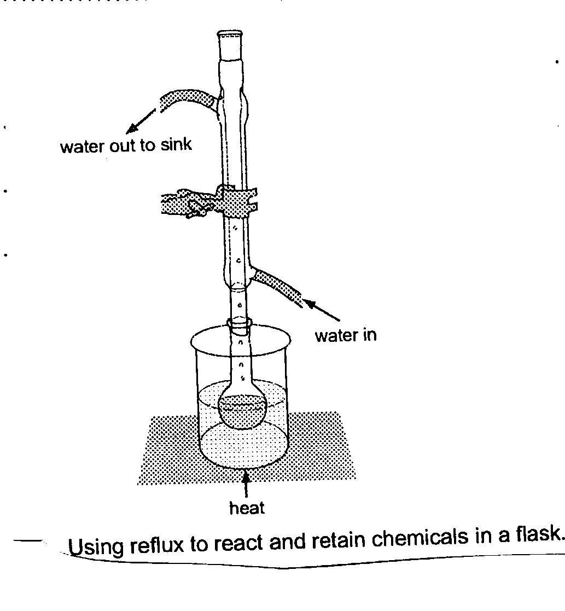

MARKS
Question 28 (4 marks)

Solutions of acids of the same concentrations were measured and given in the table below:

Acid | Concentration (mol L⁻¹) | pH
citric | 0.1 | 2.1
ethanoic | 0.1 | 2.9
hydrochloric | 0.1 | 1.0

Outcomes: H2, H8
Answer:

(a) List the acids in order of strength starting from the weakest. 1

ethanoic acid, citric acid, hydrochloric acid

(b) What is the hydrogen ion concentration of the citric acid solution?

[H⁺] = 10^{-2.1} = 7.9 x 10 ⁻³ mol L⁻¹

………………………………………………………………………………………………………
(c) Model the molecular nature and ionization of strong and weak acids in the beakers below
using the following symbols.

acid molecule

acid anion

⊕ hydrogen ion

strong acid
weak acid
⊕

⊕
⊕ ⊕

⊕ ⊕

MARKS
Question 29 (3 marks)

Aluminium carbide (Al₄C₃) reacts with excess water to produce methane (CH₄) and aluminium
hydroxide.

(a) Write the balanced formulae equation for the reaction. 1
Outcomes: H10
Answer:

Al₄C₃ + 12 H₂O → 3 CH₄ + 4 Al(OH)₃

(b) What mass of aluminium carbide is required to produce 24.71 L of methane at 25⁰C and 100 kPa? 2

Outcomes: H10
Answer:

mol CH₄ = 1 (24.79 L)
∴ mol Al₄C₃ required = 1/3 mol
or mass Al₄C₃ = mol x fw = 1/3 x ((26.98 x 4) + (3x12))
= 47.97 g

MARKS

Question 30 ( 4 marks)

A 1.0 molL⁻¹solution of sodium hydrogen carbonate was titrated in separate experiments with
hydrochloric acid and sodium hydroxide. The results are shown in the graph below. The
starting point in both titrations was the 0 position indicated on the x-axis.

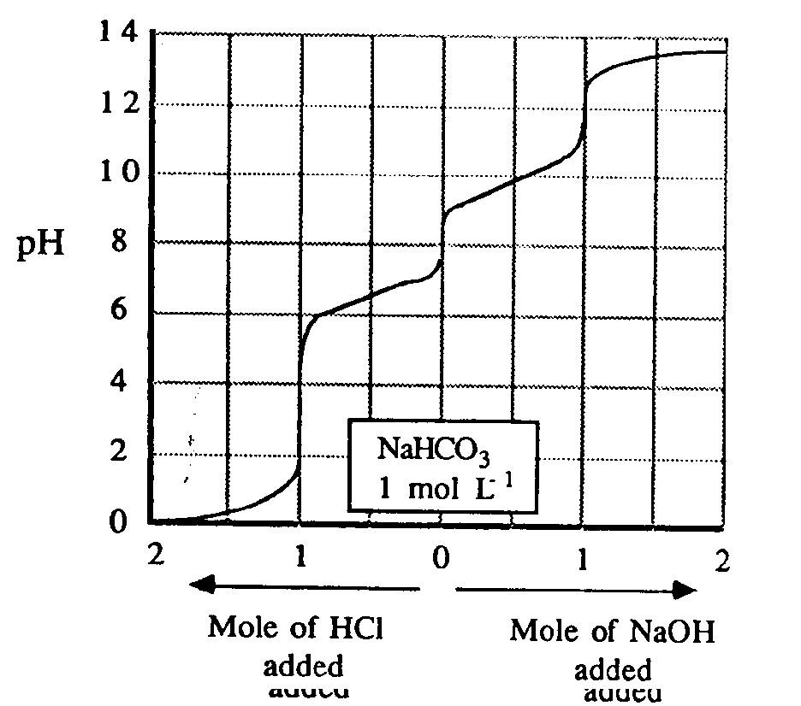
Outcomes: H8
Answer:

(a) What is an amphiprotic species? Write balanced ionic equations showing how the
hydrogen carbonate ion may react as an amphiprotic species.

An amphiprotic species can act as both a proton donor and a proton acceptor. 1

HCO₃⁻ + H⁺ → H₂CO₃ → CO₂ + H₂O
HCO₃⁻ + OH⁻ → CO₃²⁻ + H₂O 2
HCO₃⁻ + H₂O H₃O⁺ + CO₃²⁻

HCO₃⁻ + H₂O H₂CO₃ + OH⁻ (Smith: p 143)

(b) What is the pH of a 1.0 molL⁻¹ solution of sodium hydrogen carbonate?

8 1

Section II

25 marks

Attempt Question 31
Allow about 45 minutes for this section.

Answer the question in a writing booklet provided
Show all relevant working in questions involving calculations
______________________________________________________________________________________
Question 31 MARKS

(a) Write anode and cathode reactions during the electrolysis of copper (II) chloride
solution and sodium sulfate solution using copper metal electrodes and the minimum
possible voltage. 4

Criterion | Mark(s)
One mark for each equation | 1x4

Reaction at the anode and cathode during electrolysis of two solutions
Electrode | Copper(II)chloride | Sodium sulfate
Anode | Cu (s) → Cu²⁺ + 2e- | Cu (s) → Cu²⁺ + 2e-
Cathode | Cu²⁺+ 2e⁻ → Cu (s) | 2e⁻ + 2 H₂O → H₂(g) + 2OH⁻

(b) Cathodic protection is one way of protecting iron and iron-based materials from
corrosion.

Identify two applications/ techniques for corrosion prevention utilising cathodic
protection. Use relevant ionic equations to support your answer. 4
Criteria | Mark(s)
Two applications | 2
Two ionic equations | 2

Outcomes:H2,H3,H4,H5

(a)Galvanising the iron uses cathodic protection to protect the surface from corrosion.after the
zinc layer has been scratched. The coating zinc becomes the sacrificial anode
Zn(s) → Zn²⁺ + 2e⁻ anode
4 e⁻+ 2 H₂O + O₂→ 4OH⁻ cathode
2Zn(s) +2 H₂O + O₂→ 2Zn²⁺ + 4OH⁻

(b) voltage is applied to an inert (i.e. non- sacrificial) anode and the metal to be protected is
given a negative potential. The voltage forces electrons on to the metal to be protected and hence
prevents its oxidation.

4e⁻ + O₂ + 2 H₂O → + 4 OH⁻ cathode (negative electrode, the metal to be protected)
2 H₂O → O₂(g) + 4H⁺ + 4e⁻ anode (inert electrode)

(c) Discuss one technique other than cathodic protection which is used to protect a ship's metal
hull. from corrosion. 2

Criteria | Mark(s)
More detailed discussion of other methods for protection against rust | 2

Outcome:H5
Answer: Any of the following:

- Surface alloys: Formation of a stainless steel -like alloy on the surface of a ship by bombarding the surface with ions of chromium and nickel. The metal ions are formed in a high temperature plasma

- Use of new paints such as RUSTMASTER PRO, a new polymer-based paints which when cured on the surface forms a layer which is impervious to oxygen and water. Additives
in the paint react with surface atoms in the steel to form a non-conductive layer
.

(d) Discuss the nature of the corrosion that can occur if a lead gutter were nailed to a house
using tin nails

Criteria | Mark(s)
Prediction of which metal will corrode | 1
Justification for the prediction | 1

A galvanic cell can be formed at the point of contact of the two metals. The metal that is
most easily reduced (more positive reduction potential) will serve as the
cathode whereas the other metal serves as the anode: By comparing standard reduction
potentials of Sn and Pb we see that Sn will be the anode. The lead gutter will
not corrode but the Sn nails would corrode leaving the gutter on the ground.

Reduction Potential
Sn²⁺ + 2e⁻ → Sn (s) E⁰ = -0.14 v
Pb²⁺ + 2e⁻ → Pb(s) E⁰ = -0.13 v

(e) (,i.) Use the information given in the following diagram to predict the effect of low
temperatures at great depths on the rate of corrosion of a metal. Justify your prediction. 4

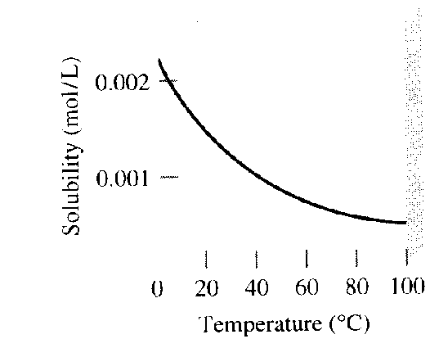
Diagram 1: Graph of solubility of O₂ gas as a function of
temperature.
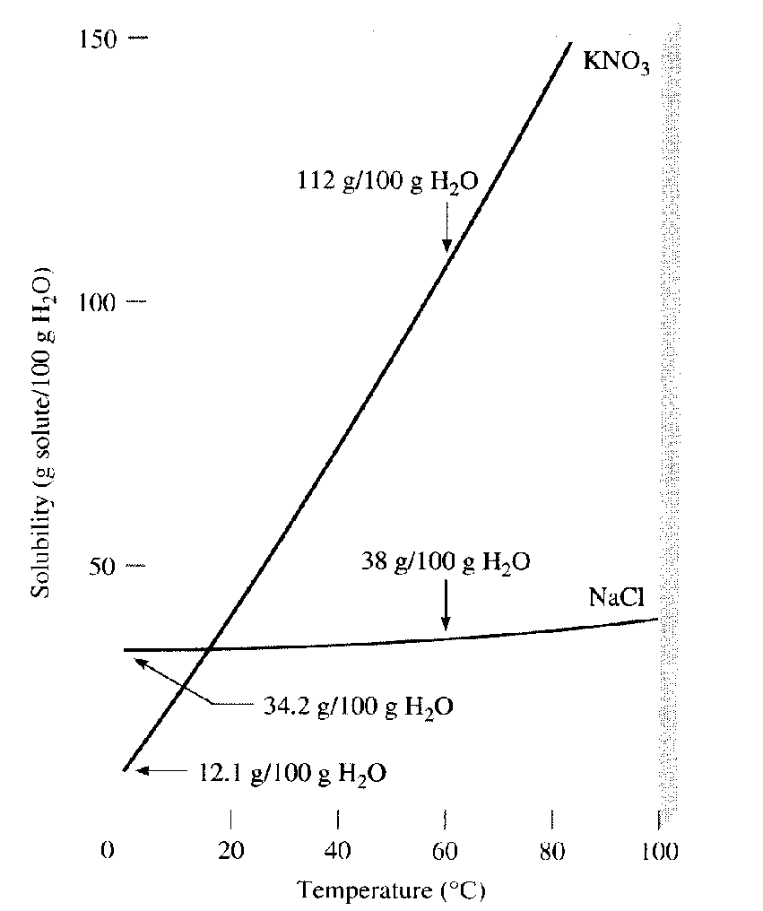Diagram 2: Graph of the solubility of solids
against temperature.
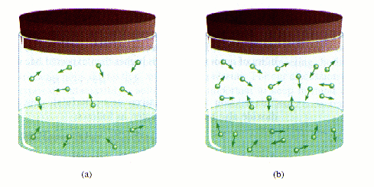
Diagram taken from Chemistry, by Chang, 1996.
Diagram 3: Effect of pressure on the solubility of a gas.

Outcomes:H14,H13,H12,H11,H8,H2
Criteria | Mark(s)
Conclusions drawn on the basis of diagrams | 2
justification of prediction | 2

Answer:
At great depths, the temperature of water is very low. At this temperature, the solubility of
oxygen as detailed in Diagram 1 is higher. A higher oxygen concentration results in a higher
rate of corrosion. On the other hand, a lower temperature should result in s lower rate of
corrosion due to the absence of the necessary activation energy required for the reaction,. The opposing factors results in a rate of corrosion which is not easily predictable. Salt concentration (NaCl) is not much affected as shown by Diagram 2 by change in temperature and hence the change in depth, will not affect the rate of corrosion by way of change in the electrolyte concentration.
(e)(ii.) Other than the information given in these diagrams, identify factors or processes that control
the concentration of oxygen and carbon dioxide in the ocean waters. 2

Criteria | Mark(s)
Factors controlling the concentration of gases | 2

Other factors that control the concentration of gases, particularly, oxygen and carbon dioxide
are the consumption of oxygen and production of CO₂ by marine plants and animals and the
consumption of CO₂ and the production of oxygen by plants.

(f) What is the best way to store partly used steel wool in the kitchen? The options available are :

- keeping it immersed in plain tap water
- keeping it immersed in soapy water (a basic solution)
- keeping it immersed in a carbonated drink

Plan an investigation to find out the option which is least conducive to rusting 7
Your plan must include the following:
- your hypothesis and a justification for this
- a brief outline of the procedure or the strategy of the determination.
- an identification of the dependent, independent and controlled variables in the
in the experiment.
- a suggestion for improving the reliability of the experiment

You should organize your answers in such a way as to explicitly address
the above 4 points

Outcomes:H11, H12, H13, H14,H15

Criteria | Mark(s)
Hypothesis | 1
Valid procedure | 2
Identification of variables | 3
Proposal to increase reliability | 1

Answer:
HYPOTHESIS: The best option is immersing the steel wool in soap solution as a basic
solution inhibits corrosion more than neutral or acidic ( carbonated)
solution. This can be shown by considering that the reduction of
oxygen is more likely in acidic than in neutral or basic solution

½ O₂ + 2H₂O + 2e⁻ → 2 OH⁻ +0.40 v
½ O₂ + 2 H⁺ + 2e⁻ → H₂O +1.23 v

PROCEDURE:

- Soak identical masses of steel wool , ideally from the same packet of steel wool into identical beakers containing identical volumes of water, soap solution and carbonated drink. Before dropping the steel wool, test each of the solutions with K₃Fe(CN)₆ reagent . A blue precipitate indicates the presence of Fe²⁺ ions.
- Set-up control beakers, beakers containing only the solutions to be tested but which do not contain steel wool
- Cover each of the solutions tightly and store under identical temperature conditions
- After a set period of time, say, 24 hours, test each of the solutions for the presence of Fe²⁺

VARIABLES
Dependent: presence of Fe²⁺ ions i.e. development of rust
Independent variable: nature of solution in contact with steel : water, soap solution, and
carbonated drink
Controlled variable: temperature, volume of test solution , size of steel wool,
immersion of the steel wool

RELIABILITY: The reliability of the experiment can be improved by repeating the experiment several times and setting up identical beakers with same conditions for the dependent variables.
If the results are reproducible, they are more reliable.

